Why did we come up with this idea?

1. Benefits of organic food
2. Organic foods are sold by retailers with higher cost than the actual cost
3. Buying directly from organic farms is difficult due to lacking of farm information and distance between farms and buyers
4. Online shopping is becoming crucial for our daily lives
5. There is no loyalty program (subscriptions,...)

Competitor in Spain: https://www.agroboca.com

**STATISTICS**

**10,231,319,945 $**

US dollars spent on organic products

<https://www.theworldcounts.com/challenges/consumption/foods-and-beverages/organic-food-statistics>

**Did you know?**

If you eat an average apple you also eat over 30 pesticides - EVEN if you washed the apple before eating it. Organic food contains no pesticides.

**Benefits of organic food**

Organic farming reduces **pollution**, conserve water, reduce **soil erosion,** increase soil fertility, and use **less energy**.

**A solution to global warming**

Organic agriculture can reduce the need of fossil fuel for crop production by 70 percent. If used worldwide, organic farming could store CO2 by an amount corresponding to a global emission reduction of 40 percent.

**The potential of organic farming**

Rice farmers in China have demonstrated that growing multiple varieties of rice in the same fields can double yields without the use of synthetic chemicals. The increase is due mainly to reductions in pest losses but partly also to more efficient nutrient uptake.

**The good news**

There are good reasons for going organic. Besides, less intensive, humane and sustainable farming can easily feed the world in 2050 if we reduce our meat consumption

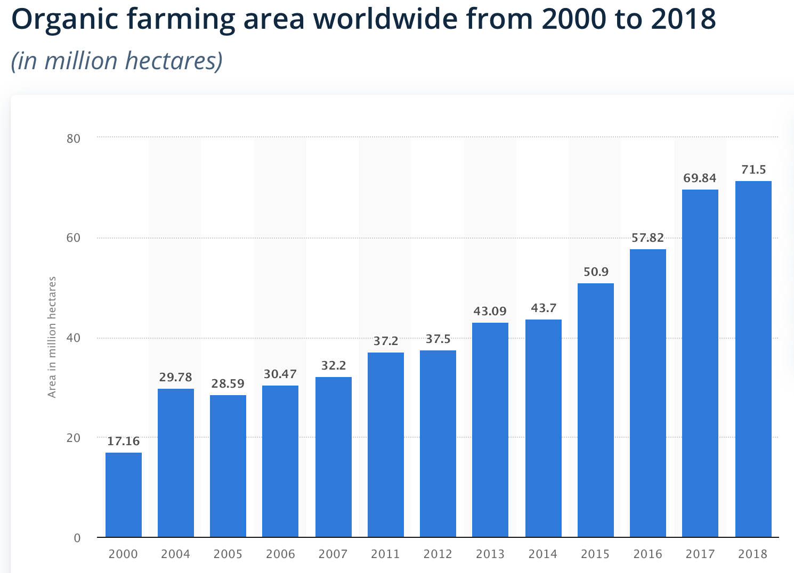

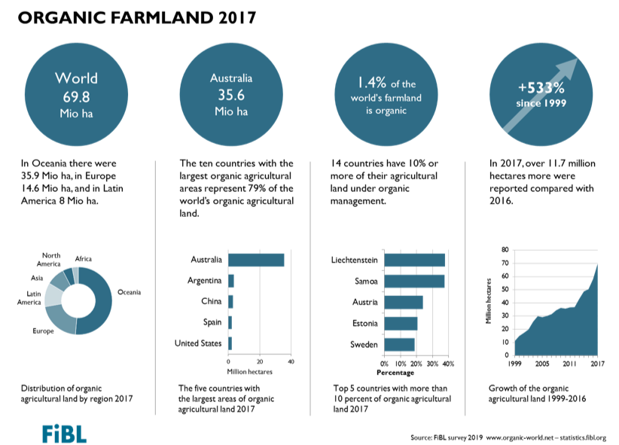

<https://www.organicwithoutboundaries.bio/2019/02/28/organic-agriculture-statistics-book-2019/>